Experiment 8
Fourier Transform Infrared Spectroscopy

Introduction
The total potential energy of a molecule is made up of its electronic, vibrational, rotational, and translational energies. Vibrational and rotational energies are associated with the vibrations and rotations of atoms, or groups of atoms, with respect to one another in a molecule. Absorption of infrared radiation causes changes in rotational and rotational-vibrational energy states. Molecules absorb at wavelengths that cause them to vibrate more quickly and to rotate at a different rate. Each vibration is associated with a specific frequency. Not all fundamental vibrations give rise to IR peaks, but enough do so that the spectrum is relatively complex.
  - Please refer to the IR handouts in lab and on reserve in the Williams library.
DO NOT USE ANY WATER DURING THIS EXPERIMENT!!!!!!!! Moisture destroys the IR salt plates.

Experimental

Supplies
Salt plates
Salt plate holder
box of disposable glass Pasteur pipettes
Dry liquid
Dichloromethane (also DCM, methylene chloride)
n-pentanol (1-pentanol)
n-octane
Methyl ethyl ketone (MEK)
toluene
m-xylene
Four 10 mL volumetric flasks
Solution cell
Five 1 mL plastic disposable syringes
One 5 mL glass syringe
Unknown MEK solution (obtain from TA)

Equipment
FT-IR

Read appendix I for the FTIR operational instructions!

Experimental Procedure
Salt plates are made of salt (NaCl or KBr) and they will absorb moisture and dissolve!!!
When you are not using the IR salt plates or the IR solution cell, clean and return them to the desiccator!! Students, if you fail do this, then your grade for this lab is zero!

Part A
Qualitative Analysis
- Wear gloves when performing this experiment and avoid moisture.
- Take a background spectrum without the IR cell by pressing the BACKGROUND key.
- Remove plates and holder from the desiccator. Do not use the IR-solution-cell for Part A! You should use the large round NaCl (or KBr) plates and a cell holder.
- Place the plates on a clean dry paper towel.
- Using a Pasteur pipette rinse the plates with a few of drops of dry dichloromethane (DCM).
- Wipe and dry with Kim-wipe tissues.
- Place about two drops of sample to be analyzed on one clean plate.
- Use a new Pasteur pipette for each solution and be careful not to contaminate the known solutions!
- Add the second clean plate, and press slightly.
- Make sure you have uniform film between plates (NO air bubbles).
- Mount between the prongs on the cell holder.
  - The surface tension of the liquid should keep the plates stuck together, unless you tip them upside down.
    - Analyze each of the following sample solutions individually. Make sure to clean the plates between solutions.
- Prepare and scan n-pentanol; identify the O→ H stretching frequency.
- Prepare and scan n-octane, identify the C→ H stretching frequency, C→ H bending frequency.
- Prepare and scan methyl ethyl ketone; identify the C=O stretching frequency.
- Prepare and scan toluene identify the C=C stretching frequency.
- Prepare and scan m-xylene, identify the C=C stretching frequency.
- When finished with Part A, clean salt plates with several volumes of (DCM) CH₂Cl₂. Use KimWipes to dry properly. Store the plates in the desiccator.
Part B
Quantitative Analysis
- You will need four clean, dry 10.0 mL volumetric flasks (they should be next to the stock IR standards).
- Using a micropipette, transfer 100 μL of methyl ethyl ketone (MEK) to a 10.0 mL volumetric flask. (note that proper correct pipette operation is required, consult TA if you do not how to use)
- Dilute to the mark with 1-pentanol and mix well.
- This gives a 1%(v/v) MEK solution.
- Repeat steps 2-3 using 200 μL, 300 μL, and 400 μL of MEK, in order to make 2%(w/v), 3%(w/v), and 4%(w/v) MEK solutions, respectively.
- To obtain a spectrum of each of these solutions:
- Use the IR solution cell of fixed path length
- You must use this round IR solution cell because this part of this experiment is quantitative!
- Take extra precaution when handling this cell. If you break the plates consult the TA. Be careful, excessive breakage will be reflected in your grade.
- Consult TA on the cleaning and sample loading procedures.
  - Cleaning this cell without its disassembly is tricky, but can be done.
  - Check to make sure the spacer path is correctly aligned!!!

- Begin the cell cleaning procedure by removing the white cell plug caps.
- Use the 5mL glass syringes provided and gently force clean dichloromethane (DCM) between the plates. If you apply too much force, the syringe pressure will rupture the salt plates.
- Rinse three times.
- Once you have cleaned the cell, use a new plastic disposable 1 mL syringe to load the cell with the first of your MEK standard solutions.
- Replace the white cell plug caps and obtain its IR spectra.
- Repeat the cleaning process and sample introduction for the other MEK standard solutions.
- Obtain an unknown from your TA
- Obtain the unknown's IR spectra as performed in step 6.
- Rinse the cell with dry dichloromethane (DCM) before storing in the desiccator.

**Special note: Verify that the carbonyl stretch increases as the MEK concentration of your solutions increase. You can do this by printing out the IR spectra of consecutive standards that you obtain and overlaying them on top of each other. Also verify that your unknown stretch is with in the range of standards.

Data Analysis
Part A
You should have labeled the peaks of interest. There is a binder containing IR spectra interpretation and peak references. You may want to look at it.
Part B
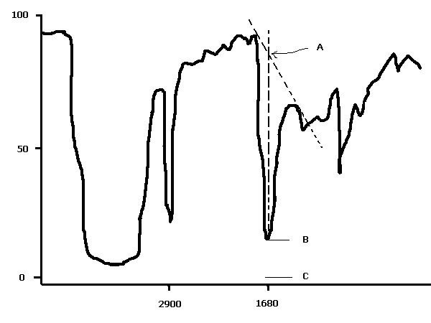For each mixture spectrum, determine the transmittance of the carbonyl-stretching signal and the transmittance of the base line at the same wavelength (by interpolation). Using the tangent baseline method as shown below, calculate the ratio of distances represented by R = (d_{BC}) / (d_{AC}). (This can be done using a ruler and measuring in centimeters!)

Tangent baseline method:

- Calculate each absorbance based on the distance ratio for each solution:
A = -log(R)
- Plot a standard curve of the four known absorbances vs respective concentrations.
- Calculate the absorbance of the unknown in the same manner that you used for the known solutions.
- Use the standard curve to determine the concentration of MEK in your unknown.

Suggested Reading
- Current Chem 2001 text: Modern Analytical Chemistry, David Harvey
- Undergraduate Instrumental Analysis. 5th Ed, By James W. Robinson.
- Handouts on reserve in CHEM 2002 laboratory, See TA.

